**Chinese Stock Market portfolio construction: based on return and ROE**

**Introduction**

Investment rely on technical analysis and value analysis are totally different way for investors. This project will deliver the difference by constructing portfolios by technical analysis: "last month return" investment and value analysis: ROE-investment.

The "last month return" investment strategy is rooted in the momentum investing approach, which posits that stocks exhibiting strong recent performance are likely to continue outperforming in the short term, while underperforming stocks will continue to struggle. This strategy is grounded in the concept that past trends and price patterns can be indicative of future performance, allowing investors to capitalize on short-term market inefficiencies and generate profits. The rationale behind this approach is that positive price momentum tends to persist, as investors may be drawn to stocks with recent gains, further fueling their upward trajectory.

ROE is a financial metric employed to evaluate a corporation's profitability in relation to its shareholders' equity. It is computed by dividing a firm's net income by its shareholders' equity. In essence, ROE illustrates the efficacy with which a company utilizes its equity base to generate profits. A higher ROE generally signifies that a company is efficiently employing its resources, thereby creating value for its shareholders.

Value investing is an investment approach that concentrates on identifying and acquiring undervalued stocks with the potential to yield significant long-term returns. Value investors seek out companies exhibiting strong fundamentals, encompassing robust financials, a competitive advantage, and a history of consistent earnings growth. The primary objective of value investing is to purchase stocks at a discount to their intrinsic value and retain them until the market acknowledges their true worth, leading to capital appreciation.

ROE is a crucial metric for value investors as it offers insights into a company's efficiency and profitability. A firm with a high ROE is likely to possess a competitive advantage, as it can generate superior returns on its equity compared to its contemporaries. This renders it an appealing target for value investors, who consistently seek companies with sustainable competitive advantages and robust financials.

**Method**

**2.1 ROE ratio**

ROE ratio (Return on Equity ratio): ROE ratio measures a company's profitability by

calculating how much profit it generates for each dollar of shareholder equity. ROE is calculated by dividing a company's net income by its shareholder equity. A high ROE ratio generally indicates that a company is efficient in generating profits from its equity, while a low ROE ratio may indicate that the company is not using its equity effectively.

$$ROE = \frac{Net Profit}{Bookvalue}$$

**2.2 Cumulative return calculation**

Cumulative return is a financial metric used to measure the total percentage change in the value of an investment over a specific period. It represents the aggregate growth or decline in the investment's value, taking into account all gains, losses, and reinvested dividends or interest.

To calculate the cumulative return, you can use the following formula:

$$Cumulative Return = \frac{Ending Value}{Beginning Value} - 1$$

In this formula, the Ending Value represents the final value of the investment at the end of the specified period, while the Beginning Value is the initial value of the investment at the start of the period. To make calculation in Stata more intuitively:

$$R_{cumulative,n}=\prod_{i = 1}^{n}{({\frac{{closing price}_{i}}{opening price}}_{i}) - 1}$$

**Result**

**3.1 Portfolio based on last month return**

Initially, we construct the most rudimentary portfolio, relying solely on the most recent return as the determining factor. We directly extract firms' monthly returns spanning December 2011 to December 2022, which serves as the foundation for generating monthly portfolios. It is imperative to utilize stock information from December 2011 to formulate a portfolio for January 2012. Consequently, we incorporate an additional month and quarter of data sourced from CSMAR.

**3.1.1 Average monthly return of portfolio (Based on last month return)**

Before we run the strategy based on last month return, we first take a for the detail of portfolio we chosen.

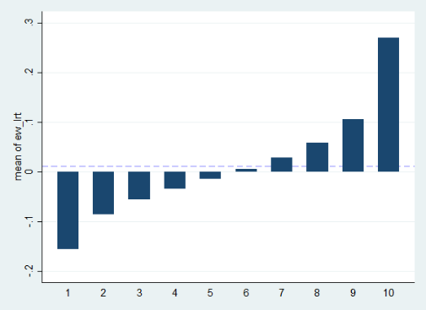In Figure 1, it is evident that five groups exhibit negative returns, while merely four groups demonstrate higher monthly returns compared to the total market return. The final group displays an exceptionally high monthly return of 26.98%, a striking contrast to the other groups, which all register less than 10%. Furthermore, the total market return stands at a mere 1.20%.

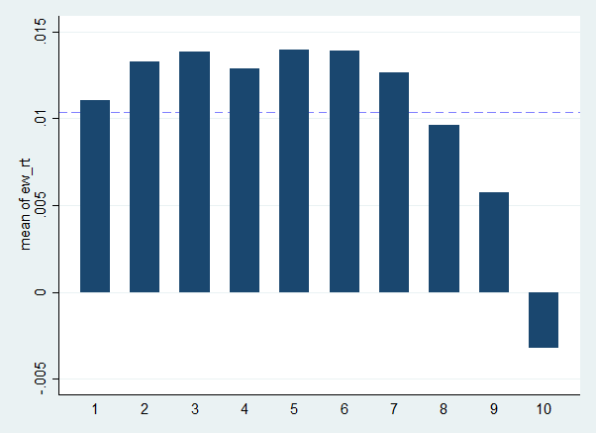

In Figure 2, it is observed that only Group 10 exhibits a negative return. For Groups 1 to 5, although initially selected based on negative returns, they subsequently generate positive returns that exceed the total market return (when calculated using an equal-weighted approach). As for Groups 6 to 9, a discernible trend emerges, indicating that a higher positive return in the preceding month corresponds to a lower return for the group. Regrettably, no significant trend can be established across all groups.

**3.1.2 Time-series cumulative return of portfolio (Based on last month return)**

As it is challenging to determine whether a portfolio generates a positive return based on the ordinary time-series, we utilized the cumulative return time series for analysis. The graph illustrates a significant separation among the ten portfolios from September 2013. Between September 2013 and January 2017, Group 1, characterized by the lowest stock return in the previous month, generated the highest cumulative return. In contrast, Group 10 consistently produced the lowest cumulative return throughout the time series. Regrettably, Group 1 did not maintain the highest cumulative return over the entire period. Instead, Group 3 surpassed it after January 2019.

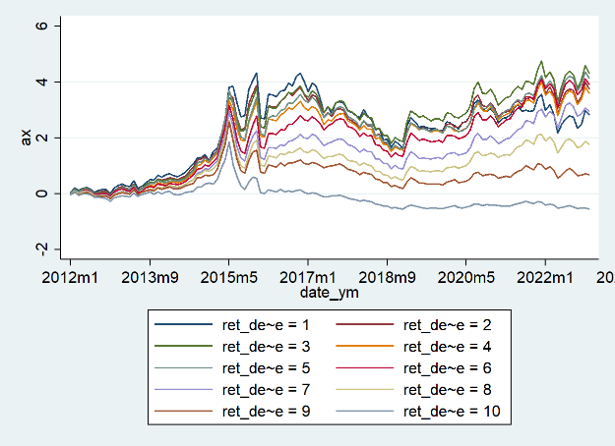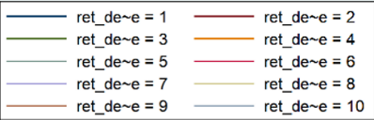

Based on these findings, we conclude that portfolios comprising stocks with low returns in the previous month can generate high returns for various reasons, while those with high returns may underperform. Historically, stocks with low valuations have exhibited a tendency to revert to their historical average valuation over time, providing opportunities for gains. Inversely, stocks with high returns may experience reversion to the mean in the form of price declines. Investors can potentially capitalize on these opportunities by constructing portfolios composed of undervalued stocks. Conversely, investing in stocks that have recently experienced high returns may prove to be an unwise decision.

**3.2 Portfolio based on ROE**

Based on the result from constructing portfolio by last month return, we derived the idea that we can make portfolio better than whole market return by only choosing undervalued stocks. One way to determine a if a stock should have more value is checking the stock’s ROE. High ROE indicates a company is effectively utilizing its equity capital to generate substantial profits, which can contribute to its increased market valuation. We constructed 10 groups based on lagged ROE.

**3.2.1 Average monthly return of portfolio (Based on ROE)**

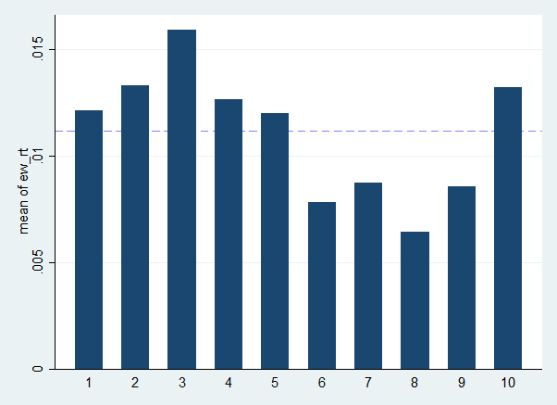Figure 4 presents the average return as a function of the previous month's ROE. It is evident that there is no conspicuous premium for Group 10, which implies that the portfolio with the highest ROE does not necessarily generate superior returns. Interestingly, Group 3, despite having a lower ROE, exhibits the largest return.

Figure 5 presents a detailed depiction of the decision-making process when selecting stocks based on ROE. The red and green lines represent the median ROE for each quarter in Group 10 and Group 1, respectively. The blue line illustrates the ratio of the medians, denoted 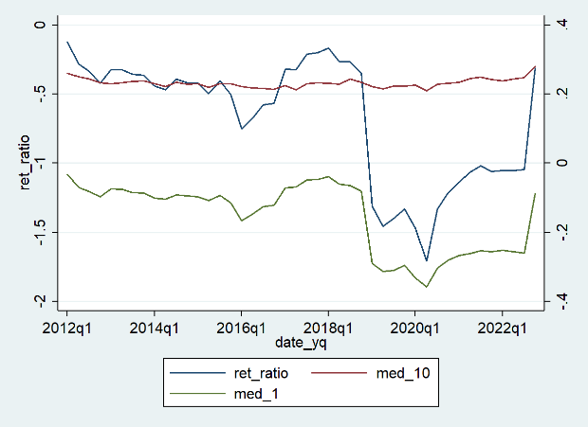as Function 1. As observed in Figure 5, the red line remains relatively stable, while the blue and green lines exhibit considerable fluctuations.

An analysis of the median ROE statistics within the ROE groups reveals that in the first quarters of 2016, 2018, and 2020, low ROE companies demonstrate a significant downward trend. This trend suggests that the fundamental performance stability of low ROE companies is inferior to that of high ROE companies, potentially exposing them to increased risks.

**3.2.2 Time-series cumulative return of portfolio (Based on ROE)**

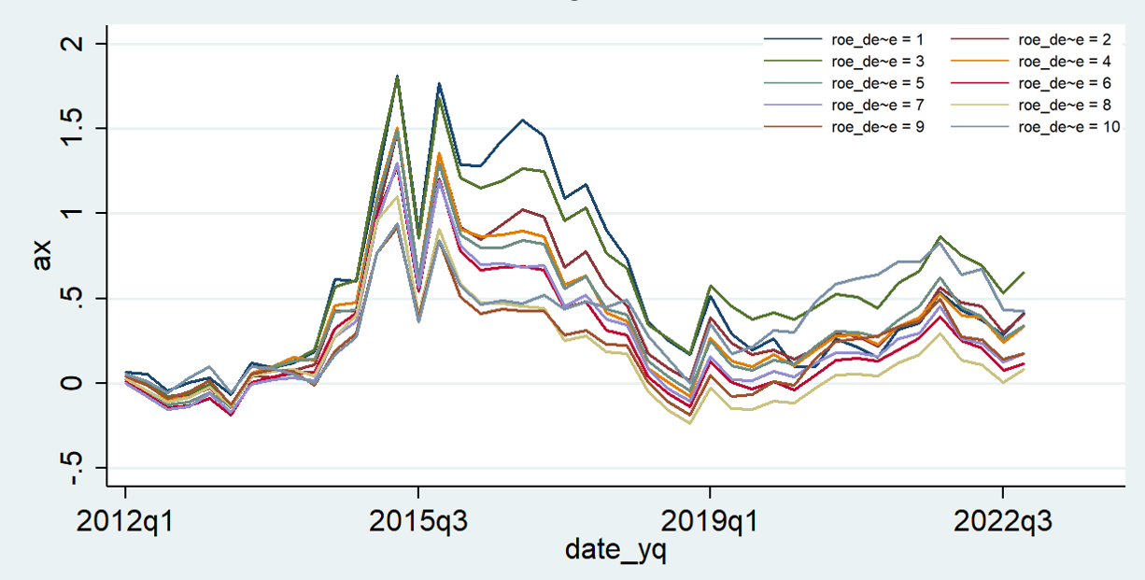Figure 6 demonstrates that a portfolio constructed solely based on the ROE indicator does not yield significant excess returns in the long term. Examining the performance of individual groups reveals that Group 3 possesses a relatively high advantage during 2014-2015, 2019-2020, and post the first quarter of 2022. However, Group 1 and Group 10 portfolios display return advantages in 2016-2018 and 2020-2021, respectively. The cumulative rate of return indicates that, when relying exclusively on the ROE indicator, both high ROE and low ROE portfolios may hold an advantage, suggesting that such a portfolio may not be a reliable investment option.

**3.2.3 Time-series cumulative return of portfolio (Based on ROE overvalued)**

During the construction of investment portfolios, we observed that relying solely on ROE indicators for investment is not reliable, as low ROE companies may encounter operational bottlenecks, and high ROE companies may be overvalued. Consequently, we aimed to identify the linear relationship between the return rate and the ROE index and select companies at the lower end of the linear relationship (i.e., significantly undervalued companies) to invest according to this classification.

Specifically, we conducted a monthly regression between the ROE index and the stock return rate of each preceding quarter, obtaining the residual value corresponding to each stock. We defined the degree to which a stock is overvalued or undervalued based on the stock's residual value: the smaller the residual value, the more severe the undervaluation; the larger the residual value, the more severe the overvaluation.

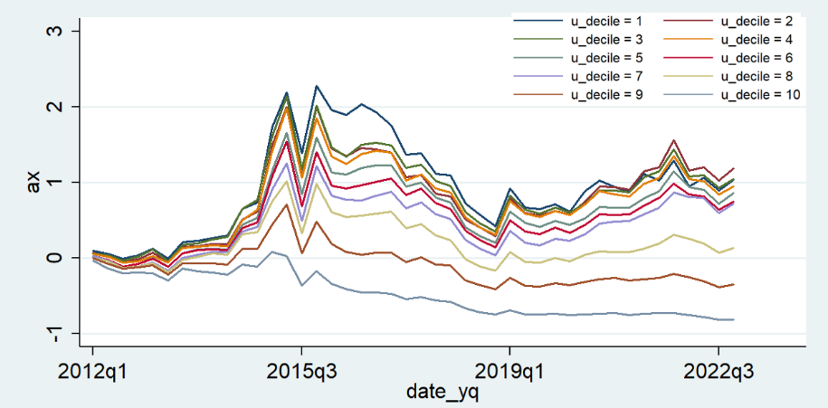Figure 7 demonstrates that this combination yields significant excess returns in the long term. From the perspective of group performance, the Group 1 portfolio consistently outperforms other groups, indicating that value stocks produce significant excess returns in the long run. Although Group 2 surpasses Group 1 to attain the highest yield by the end of 2022, a considerable yield gap remains with other combinations.

**Discussion**

We explore two investment strategies based on the “last month return” and ROE investment respectively. Turns out on the long-run, ROE investment is more reliable

An investment strategy based on last month return turns out be a failure on monthly degree. The investment result goes on the contrary than we expected. It did not follow that positive price momentum tends to persist. On the contrary, we get portfolio have better return with less return on last month, which may be caused by under-valuation (strategy for value analysis).

An investment strategy based on ROE are searching companies with strong profitability. This approach is more closely related to value investing, as it emphasizes the importance of the company's financial health and intrinsic value. Although we meet difficulty construct portfolio based on ROE directly, we find the ROE undervalue strategy. It is critical for us understanding how the investment portfolio are generated, and then it is convenient to refine our strategy.

In conclusion, the last month return approach tends to focus on short-term price trends and might overlook the underlying fundamentals of a company. As a result, this strategy may not be compatible with the principles of value investing, which prioritize long-term growth and the intrinsic value of a stock. On the other hand, the ROE-based investment strategy aligns more closely with value investing principles, as it emphasizes a company's financial health and efficiency in generating profits.

**Limitation**

There are abundant limitations for portfolio constructed based on last month return, we do not have significant granularity for technical analysis and we could not recognize the enterprise we chosen; thus, we only focus the limitation of ROE investment in this project.

The first limitation is we did not separate stocks with different industries. ROE values can vary significantly across different industries, making it challenging to directly compare companies from disparate sectors. A high ROE might be standard in one industry but considered low in another.

The second limitation is we possess only one indicator. Most time ROE is used with P/B ratio or P/E ratio. This project overemphasis the role of ROE might result in an incomplete understanding of a company's financial health.